**Linux filesystems**

* Basic filesystem functions
* Disk storage is a necessity that brings with it some interesting and inescapable details. Obviously, a filesystem is designed to provide space for non-volatile storage of data; that is its ultimate function. However, there are many other important functions that flow from that requirement.
* Filesystems also require **an Application Programming Interface (API)** that provides access to system function calls which manipulate filesystem objects like files and directories.
* APIs provide for tasks such as creating, moving, and deleting files. It also provides algorithms that determine things like where a file is placed on a filesystem.
* Such algorithms may account for objectives such as speed or minimizing disk fragmentation.
* Modern filesystems also provide a security model, which is a scheme for defining access rights to files and directories.
* The Linux filesystem security model helps to ensure that users only have access to their own files and not those of others or the operating system itself.
* The final building block is the software required to implement all these functions. Linux uses a two-part software implementation to improve both system and programmer efficiency.

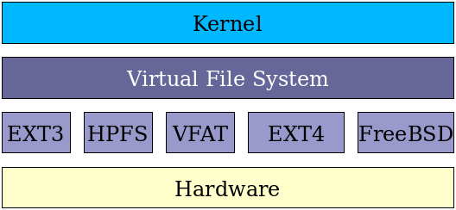

The first part of this two-part implementation is the Linux virtual filesystem. This virtual filesystem provides a single set of commands for the kernel, and developers, to access all types of filesystems.

**Directory structure**

I like things stored in smaller, organized groups rather than in one big bucket.

The use of directories helps me to be able to store and then locate the files I want when I am looking for them.

Directories are also known as folders because they can be thought of as folders in which files are kept in a sort of physical desktop analogy.

In Linux and many other operating systems, directories can be structured in a tree-like hierarchy.

The Linux directory structure is well defined and documented in the Linux Filesystem Hierarchy Standard (FHS).

Referencing those directories when accessing them is accomplished by using the sequentially deeper directory **names connected by forward slashes (/) such as /var/log and /var/spool/mail. These are called paths.**

| **Directory** | **Description** |
| --- | --- |
| / (root filesystem) | The root filesystem is the top-level directory of the filesystem. It must contain all of the files required to boot the Linux system before other filesystems are mounted. It must include all of the required executables and libraries required to boot the remaining filesystems. After the system is booted, all other filesystems are mounted on standard, well-defined mount points as subdirectories of the root filesystem. |
| /bin | The /bin directory contains user executable files. |
| /boot | Contains the static bootloader and kernel executable and configuration files required to boot a Linux computer. |
| /dev | This directory contains the device files for every hardware device attached to the system. These are not device drivers, rather they are files that represent each device on the computer and facilitate access to those devices. |
| /etc | Contains the local system configuration files for the host computer. |
| /home | Home directory storage for user files. Each user has a subdirectory in /home. |
| /lib | Contains shared library files that are required to boot the system. |
| /media | A place to mount external removable media devices such as USB thumb drives that may be connected to the host. |
| /mnt | A temporary mountpoint for regular filesystems (as in not removable media) that can be used while the administrator is repairing or working on a filesystem. |
| /opt | Optional files such as vendor supplied application programs should be located here. |
| /root | This is not the root (/) filesystem. It is the home directory for the root user. |
| /sbin | System binary files. These are executables used for system administration. |
| /tmp | Temporary directory. Used by the operating system and many programs to store temporary files. Users may also store files here temporarily. Note that files stored here may be deleted at any time without prior notice. |
| /usr | These are shareable, read-only files, including executable binaries and libraries, man files, and other types of documentation. |
| /var | Variable data files are stored here. This can include things like log files, MySQL, and other database files, web server data files, email inboxes, and much more. |

Table 1: The top level of the Linux filesystem hierarchy.

The directories and their subdirectories shown in Table 1, a

The following table provides a very brief list of the standard, well-known, and defined top-level Linux directories and their purposes.

For more details: <https://opensource.com/life/16/10/introduction-linux-filesystems>